- 填空题
1：假设
String s1 = "Welcome to Java";
String s2 = s1;
String s3 = new String("Welcome to Java");
那么下面表达式的结果是什么？
(1) s1 == s2 ______true______________________
(2) s1 == s3 ______false______________________
(3) s1.equals(s2) ______true______________________
(4) s2.equals(s3) ______true______________________
(5) s1.compareTo(s2); ______0______________________
(6) s2.compareTo(s3); ______0__________________________
(7) s1.charAt(0); ______W__________________________
(8) s1.indexOf('j'); ______-1__________________________
(9) s1.indexOf("to"); ______8__________________________
(10) s1.lastIndexOf("o",15) _____9__________________________
(11) s1.substring(3, 11); ______come to____________________
(12) s1.endsWith("Java") _______true_____________________
(13) s1.startsWith("wel"); ___________false________________
(14) " We come ".trim(); ____________We come_________________
(15) s1.toUpperCase(); ____________WELCOME TO JAVA__________
(16) s1.replace('o', 'T'); _____________welcTme tT java________

2．如果
StringBuffer s1 = new StringBuffer("Java");
StringBuffer s2 = new StringBuffer("HTML");
假设下列每个语句是独立的，每条语句结束后，写出相应结果
(1) s1.append(" is fun"); s1为_____Java is fun_________
(2) s1.append(s2); s1为_____Java HTML_________
(3) s1.insert(2, "is fun"); s1为______jais funva_______
(4) s1.insert(1,s2); s1为______JHTMLava_________
(5) char c = s1.charAt(2); c为_____v_________________
(6) int i = s1.length(); i为_____4_________________
(7) s1.deleteCharAt(3); s1为_____Jav________________
(8) s1.delete(1,3); s1为______Ja_______________
(9) s1.reverse(); s1为_______avaJ______________
(10) s1.replace(1,3, "Computer"); s1为_______JComputera______
(11) String s3 = s1.substring(1,3);
s3为_____av______________，s1为_________Java___________
(12) String s4 = s1.substring(2);
S4为______va_________________，s1为________Java_____________

3. 假设StringBuffer s = new StringBuffer("Welcome to JAVA");
将s的内容清空的语句是_________s.delete(0,s.length());__________

4.如果
String s1 = "Welcome";
String s2 = new String("Welcome");
String s3 = s2.intern();
String s4 = "Wel" + "come";
String s5 = "Wel";
String s6 = "come";
String s7 = s5 + s6;
String s8 = "Wel" + new String("come");
那么下面表达式的结果为：
（1）s1 == s2 ___false_________
（2）s1 == s3 _____true_______
（3）s1 == s4 ______true_____
（4）s1 == s7 ______false______
（5）s1 == s8 _______false_____
（6）s1.equals(s2) ___true_________
（7）s1.equals(s3) ____true________
（8）s1.equals(s4) _____true_______
（9）s1.equals(s7) ______true______
（10）s1.equals(s8) ______true______

二、单项选择题
1．可以获取字符串s的最后一个字符的表达式是____c____。
（A）s.length()
（B）s[s.length() - 1]
（C）s.charAt(s.length() - 1)
（D）charAt(s, length(s))

2. 下面程序
class C {
public static void main(String[] args) {
String s = “null”;
if(s == null)
System.out.print(“a”);
else if(s.length() == 0)
System.out.print(“b”);
else
System.out.print(“c”);
}
}
的输出为____c____。
（A）a （B）b
（C）c （D）null

3. 下面的程序
class C {
public static void main(String[] args) {
String s = “Welcome to ”;
concat(s);
System.out.print(s);
}
public static void concat(String s) {
s += “Java”;
}
}
的输出为___A_____。
（A）Welcome to （B）Welcome to Java
（C）编译错误 （D）运行时异常

三、编程题
1：统计字符串中每个英文字母出现的次数并输出到控制台（大小写不敏感）。
import java.util.Scanner;

public class LetterCounter {
public static void main(String[] args) {
Scanner input = new Scanner(System.in);
System.out.print("输入字符串：");
String s = input.nextLine().toLowerCase();
int[] counts = new int[26];
for (char c : s.toCharArray()) {
if (Character.isLetter(c)) {
counts[c - 'a']++;
}
}
for (int i = 0; i < 26; i++) {
if (counts[i] > 0) {
System.out.println((char) ('a' + i) + ": " + counts[i]);
}
}
}
}
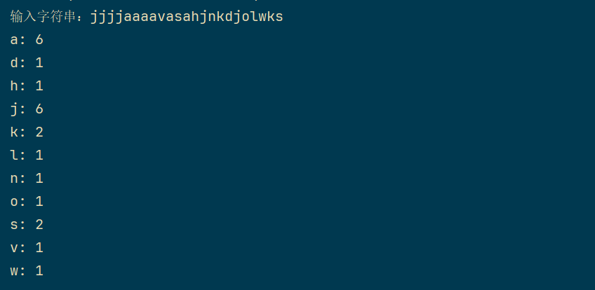
2：假设一个车牌号码由三个大写字母和后面的四个数字组成。编写一个程序. 生
成5个不重复的车牌号码。
import java.util.*
public class Generator {
public static void main(String[] args) {
Set<String> plates = new HashSet<>();
Random random = new Random();
while (plates.size() < 5) {
StringBuilder plate = new StringBuilder();
for (int i = 0; i < 3; i++) {
char c = (char) ('A' + random.nextInt(26));
plate.append(c);
}
for (int i = 0; i < 4; i++) {
int num = random.nextInt(10);
plate.append(num);
}
plates.add(plate.toString());
}
for (String plate : plates) {
System.out.println(plate);
}
}
}

